Rudra Modi

ruraina@microsoft.com

Abstract

Learn how to leverage the Dynamics 365 Health Accelerator integration with MS Teams through this Setup Guide

Dynamics 365   
health accelerator   
TeaMS INTEGRATION

Microsoft Corporation

Contents

No table of contents entries found.

# Overview

This document outlines the setup guide for enabling MS Teams integration with the Health Accelerator. Once the setup is complete, you can use MS Teams for collaboration in a Patient’s context. When a Care Team is created in Dynamics, a MS team is created in context of a Patient. When a Care Team Participant is added to the Care Team, the participant is also added as a member to the MS team. You can also pin the Patient record in Dynamics to the Team. This can help enable collaboration and maintain context without switching apps.

If you are looking for information on the health accelerator such as the API reference or examples for extending the model, please look [here](https://community.dynamics.com/365/b/healthaccelerator/dashboard).

# Components of the Accelerator

The accelerator consists of several components as shown below. The scope of this document is to outline how MS Teams can be used in context of the HealthCare Accelerator.

* Entity Model: extensions to the Microsoft Common Data Model
* UCI App: Customer Engagement sample UCI App
* Legacy App: Customer Engagement Legacy App
* *Office: The current document indicates how MS Teams can be used in context of the Healthcare Accelerator
* *Power BI: We are working on Power BI extensions and samples
* *AI / Azure: We are working on AI / Azure extensions and samples

# Pre-requisites

* Required Roles - Office Global Administrator
* License - Enable MS Teams on your tenant. To check if you are applicable for trial, navigate to <https://teams.microsoft.com> and note the trial setup options.
* Care Team Participants should be contacts in Dynamics with the tenant email. This is they way they would be identified as users in the Active Directory of the tenant.

# Setup - Teams Integration Package

## Import Entity Model Extensions

Navigate to your Dynamics application-> Settings -> Solutions -> Create solution ‘HealthCare with Teams Integration’

The following entities need to be added/extended for the integration scenario -

* Care Team –
  + Navigate to the entity
  + Enable change tracking
  + Add a new field called ‘OfficeGroupsID’ as per below ->

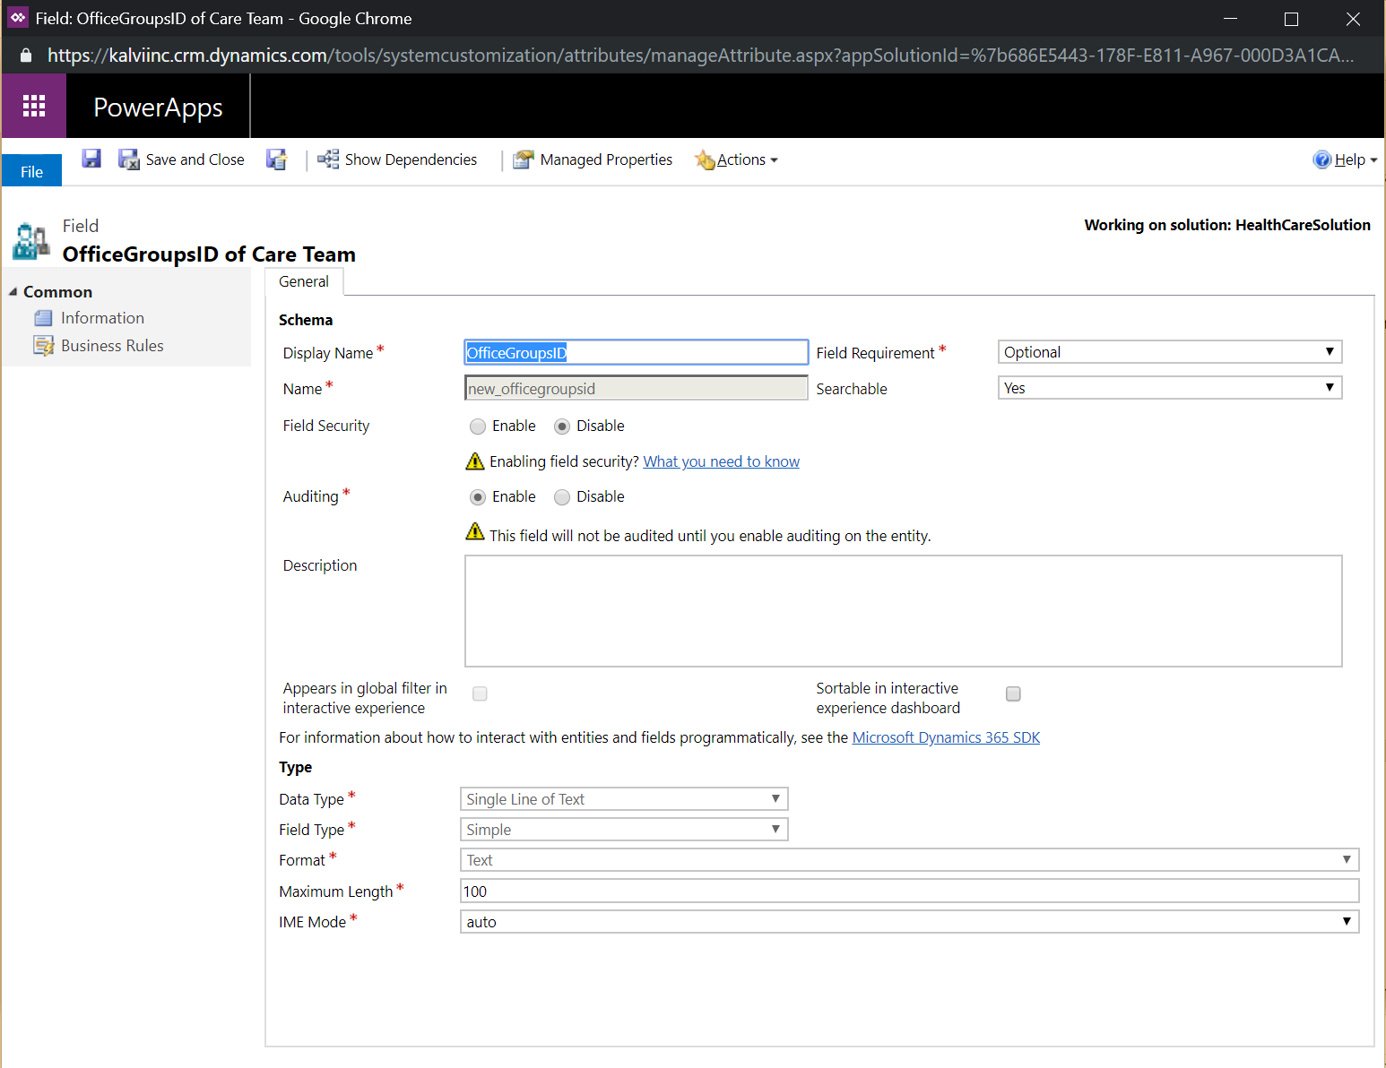

* Care Team Participants
  + Navigate to the entity
  + Enable change tracking
* Publish customizations

## Azure Application Registration for Office Group Authorization

* Register a new Azure AD Application in your Azure AD as shown below

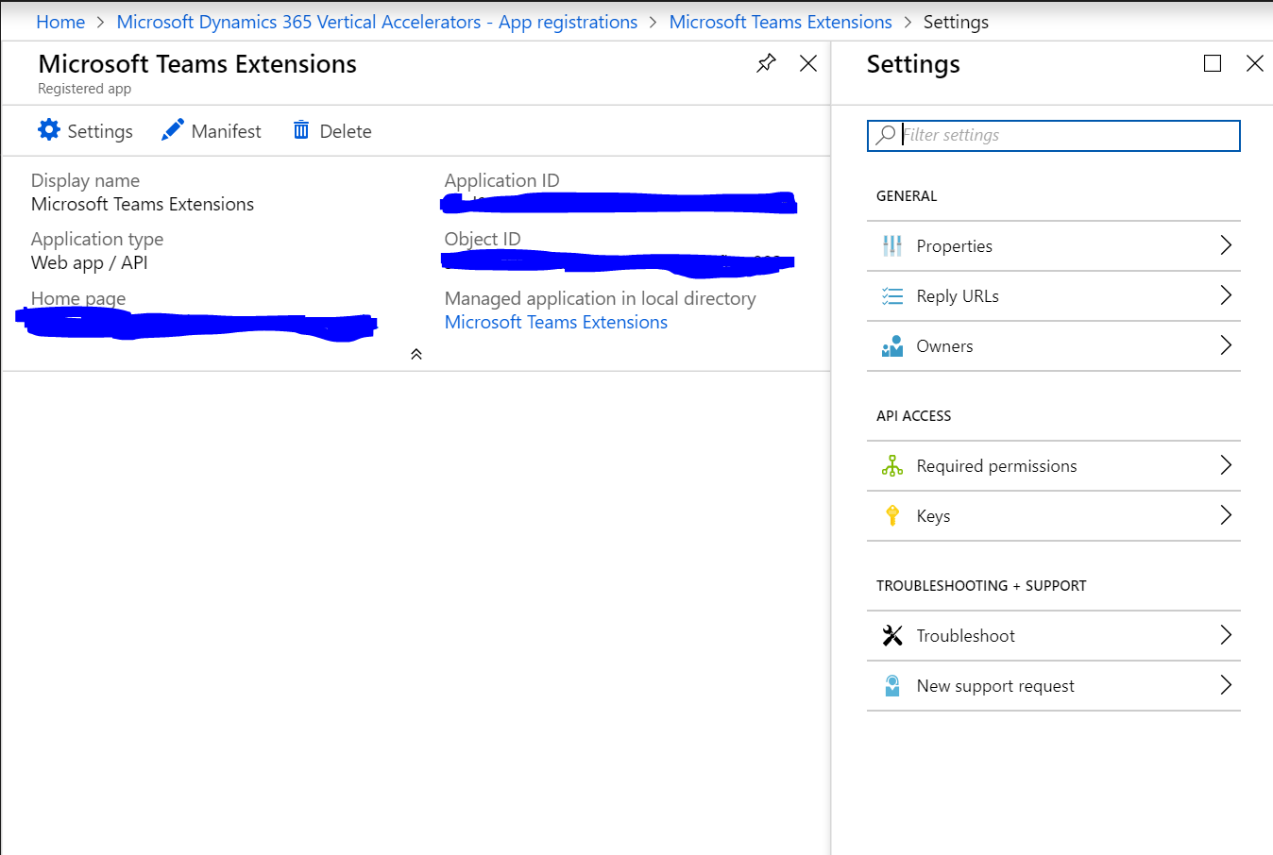

* Copy the ApplicationID as generated above. This will be used in next step.
* Navigate to Keys. Generate a new Key that never expires and save that for next steps
* Add the Microsoft Graph permission for delegated "Read and write all groups" (Group.ReadWrite.All) and "Access user's data anytime" (offline_access).
* Click on Grant permissions

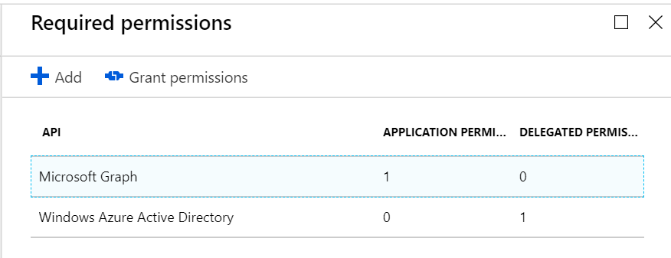

## Custom Connector for Creating Teams

Follow the below steps to register the custom connector for Creating MS Teams from Flow

* Navigate to <https://flow.microsoft.com> and Signin using your Global Admin credentials
* Navigate to settings and click on ‘Custom Connectors’

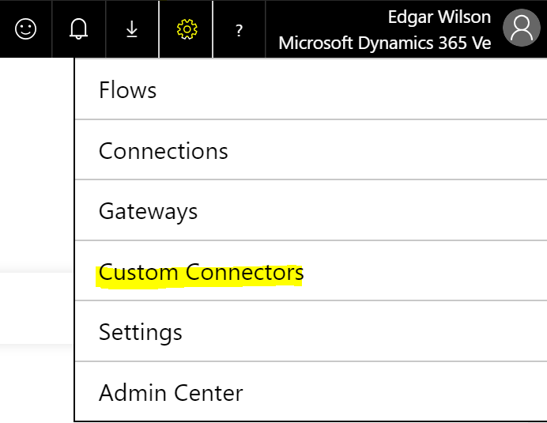

* Click on ‘Create custom connector’ and ‘Import an OpenAPI file’

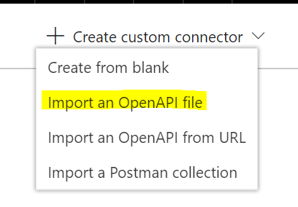

* Set the custom connector name and click on Import. Choose the *swagger.json* file from the repo -> [Dynamics-365-Industry-Accelerators](https://github.com/Microsoft/Dynamics-365-Industry-Accelerators/tree/healthcare)/[health](https://github.com/Microsoft/Dynamics-365-Industry-Accelerators/tree/healthcare/health)/[samplecode](https://github.com/Microsoft/Dynamics-365-Industry-Accelerators/tree/healthcare/health/samplecode)/**office** folder

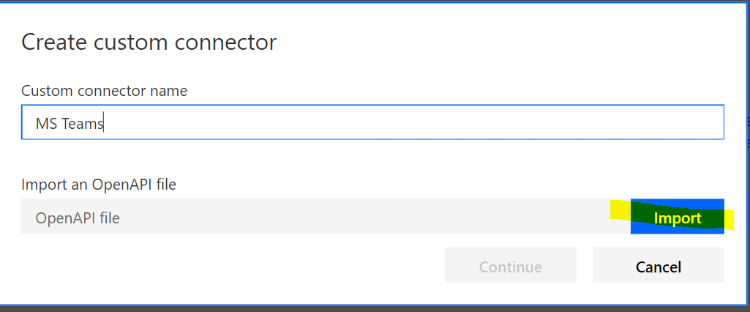

* Verfiy the following settings: Scheme: (x) HTTPS; Host: "graph.microsoft.com"; Base URL "/" and continue
* For authentication type choose "OAuth 2.0"
* Select "Generic Oauth 2" as Identity provider
* Paste Client Id generated from Azure Application registration step
* Paste Client secret from Azure application registration step
* Authorization URL: "<https://login.microsoftonline.com/_yourtenant_.onmicrosoft.com/oauth2/v2.0/authorize>"
* Token URL: "<https://login.microsoftonline.com/_yourtenant_.onmicrosoft.com/oauth2/v2.0/token>"
* Refresh URL: ""<https://login.microsoftonline.com/_yourtenant_.onmicrosoft.com/oauth2/v2.0/token>"
* Scope: "Group.ReadWrite.All"
* Create the connector
* Navigate to the security tab again and copy the "Redirect URL" and register URL as Reply URL in your Azure AD App(created in above step) within the Azure Portal

## Import Flows and Map Connectors

* Login to <https://flow.microsoft.com> and go to Settings->Connections.
* Add the following connections there ->Azure AD, Teams, Dynamics, Custom connector created above.
* Navigate to ‘My Flows’ and click on Import. Import the two flows (*CreateTeamFlow* and *CreateTeamMembersFlow*) from the repo

[Dynamics-365-Industry-Accelerators](https://github.com/Microsoft/Dynamics-365-Industry-Accelerators/tree/healthcare)/[health](https://github.com/Microsoft/Dynamics-365-Industry-Accelerators/tree/healthcare/health)/[samplecode](https://github.com/Microsoft/Dynamics-365-Industry-Accelerators/tree/healthcare/health/samplecode)/**office** one by one. While importing, map each connection in the flow with the connections created in the above step.

## Pin Patient record to Teams

Once the setup is completed and you have created Care Teams for your patients, you can also navigate to the MS Team for the patient and pin the Dynamics record for the patient there. This will enable easier collaboration between care team participants while keeping the context of the patient intact.

* Click on +
* Search for Dynamics connector

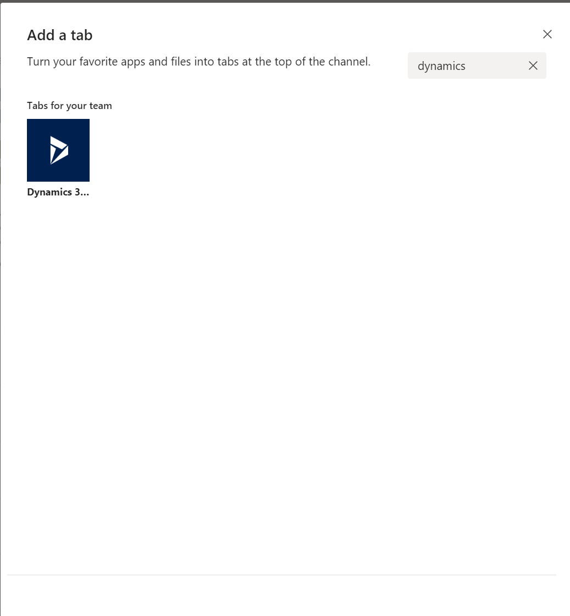

* Select Orgname,AppModule, Entity(Contact) and choose the Patient record
* That should pin the patient record as shown below.

